

**KABARAK UNIVERSITY**

**UNIVERSITY EXAMINATIONS**

**MAIN CAMPUS**

**SECOND SEMESTER 2020/2021 ACADEMIC YEAR**

**EXAMINATION FOR THE DEGREE OF BACHELOR OF SCIENCE IN COMPUTER SCIENCE, BACHELOR OF SCIENCE IN TELECOMMUNICATIONS, BACHELOR OF SCIENCE IN EDUCATION, BACHELOR OF SCIENCE (GENERAL)**

**PHYS 120 BASIC ELECTRONICS**

**STREAM: Y1S1 TIME:**

**EXAMINATION SESSION: DATE:** 

**INSTRUCTIONS:**

***Answer Question 1 and any other two***

**QUESTION 1 (30 MARKS)**

1. Give Four comparisons between FET and BJT. [4 Marks]
2. Draw symbols of the following devices:
3. Zener diode [1Mark]
4. Rectifier diode [1Mark]
5. LED [1Mark]
6. For the radio circuit is given below (Fig.1):
   1. Identify the transistor connection mode used in the amplifying stages [1Marks]
   2. Explain why several stages of amplification were used. [2Marks]
   3. The typical gain βDc of BC 199 transistor is 85. Find for the first stage of amplification:
      1. Current flowing through R2. [4 Marks]
      2. VCE of Q1 [3 Marks]

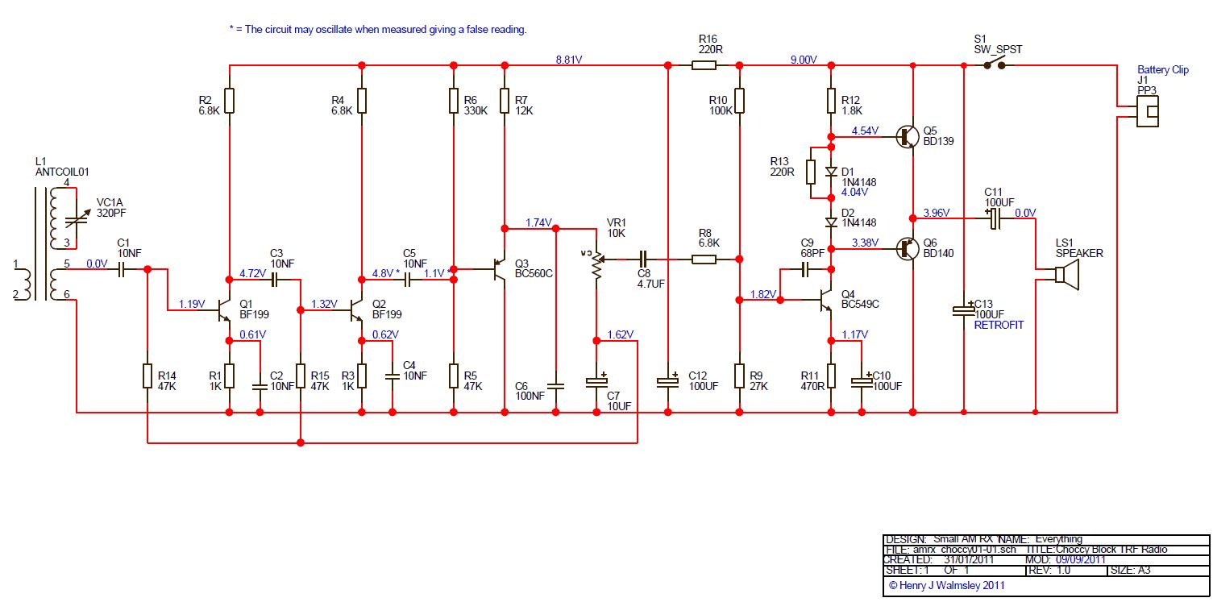

Figure 1

1. Explain how the bandgap can be used to distinguish between conductors, semiconductors and insulators. [6 Marks]
2. With regard to BJT, explain why:
   1. The collector is normally made larger than the other two regions. [2 Marks]
   2. It is considered slower in switching than FETs. [2Marks]
3. What is the value of βDC of the transistor in Fig. 2? [3Marks]

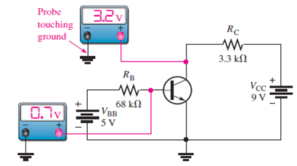

Figure 2

**QUESTION 2 (20 MARKS)**

1. Explain the formation of depletion layer in a pn junction. [4 Marks]
2. A pn junction has NA=1019 cm-3 and ND =1018cm-3. If ni = 1020 cm-3 find its built in potential 300 K . [4 Marks]
3. In Figure 3, Vin = 10 Volts.
   * 1. Give the name of the circuit. [1 Marks]
     2. Explain the operation of the circuit. [3 Marks]
4. Find voltage across AB. [2 Marks] 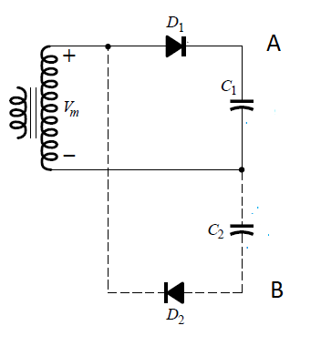

Figure 3

1. Describe any two methods the following method of fabrication pn junction diode.
2. Grown junction [3 Marks]
3. Alloying [3 Marks]

**QUESTION 3 (20 MARKS)**

1. Give two examples for each of the following:
2. Donor impurity. [2 Marks]
3. Acceptor impurity. [2Marks]
4. Draw typical transistor characteristics of a common emitter mode and Marks the following regions.
   1. Saturation [2 Marks]
   2. Cut- off [2 Marks]
   3. Breakdown[2Marks]
5. For the circuit below (Fig 4):
   1. Determine the Q point values. [6 Marks]
   2. Draw the loadline and Marks the Q point [4 Marks]

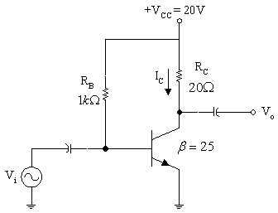

**Figure 4**

**QUESTION 4 (20 MARKS)**

1. Determine the approximate values for each of the following quantities in Figure 5.

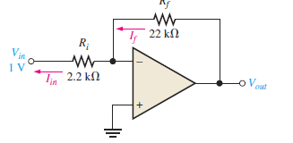

Figure 5

* 1. *I*in [2 MARKS]
  2. *I*f [2 Marks]
  3. *V*out [2 Marks]
  4. closed-loop gain [2 Marks]

1. Electronics plays key role in modern computers. Identify SIX functions or parts of the computer which require electronic parts. You must state the role of the part/function you identify. [12 Marks]

**QUESTION 5 (20 MARKS)**

1. Explain the role of all the components in the Figure. 1.2. [4Marks]

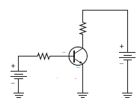

1. Draw a well-biased circuit n-channel JFET and sketch the transfer curve defined by *IDSS =*12 mA and *VP=* 6 V. [8 Marks]
2. Derive the collector current of the follwing biasing methods.:

### Collector Feedback Bias [4 Marks]

### Potential divide bias [4 Marks]